## Pitch, roll, sway and heave

For pitch, roll, sway and heave we recommend the Ship motion SMC108. SMC has developed its IMU range of Motion Sensors to meet the requirements of the marine sector. The IMU range provides high accuracy motion measurement data in dynamic environment in all areas from small hydrographic vessels to large oil rigs in all weather conditions.



*: For more information we refer you to the SMC108 manual*

The SMC108 will be connected to the serial port of a moxa that is connected to the NavVision system. In NavVision you can go to tools/configuration/serial/serial lan ports and there choose the NMEA protocol from the drop down menu (see Figure 2‑1). For more information on how to install and set-up the Moxa, we refer you to the “software installation and commissioning manual”.

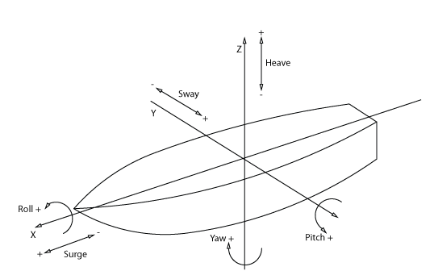

Figure 2‑2: Ships movement explained